**SRM INSTITUTE OF SCIENCE AND TECHNOLOGY**

**SCHOOL OF COMPUTING**

**PROJECT 2024 – 2025**

**VIII Semester**

**General Instructions for 18CSP109L-Project (10 Credits) / 18CSP111L- Project (7 Credits)**

* Students can choose **18CSP109L – PROJECT (10 CREDITS)** course or **18CSP111L – Project (7 CREDITS) with 18CSP112L – Internship (3 Credits)** courses in their 8th semester. Students must earn ten credits in their 8th semester
* Students placed through SRM Placements with Internship offers can choose **18CSP111L – Project (7 CREDITS) with 18CSP112L – Internship** courses in their 8th semester.
* Students who are carrying forward their minor projects should proceed with their current work for the upcoming major projects. The schedule for the first review, along with the necessary templates, will be shared in due course.
* **The zeroth review is scheduled only for students who are starting new projects for their major Project.**
* Those opting for new projects should prepare the following documents for their review.

|  |  |  |  |
| --- | --- | --- | --- |
| **REVIEW DETAILS** | **DATES**  **(Tentative)** | **WORK TO BE COMPLETED (Research Projects)** | **WORK TO BE COMPLETED (Product-based Projects)** |
| Project Review – 0 | 16 November 2024 | Abstract  Introduction to project  Literature survey in table format (Template attached)  Limitations Identified from Literature Survey (Research Gaps)  Research Objectives (Can be considered as epics)  Justification of Project SDG  Plan of action (Timeline) | Abstract  Introduction to project  Product Vision Statement (Template Attached)  Prepare a Detailed Product Backlog (Template Attached)  (The student team needs to prepare a detailed product backlog that consists of epics, sprints, prioritization, functional, and non-functional requirements.)  Justification of Project SDG  Product Road Map (Timeline) |

* Projects are periodically reviewed by the project panel and the progress should be recorded.
* During the reviews, Students should present and demonstrate their project and submit the required documents in a well-structured format**.**
* Projects must be visualized to the public audience through project expo, which will be organized by the project coordinators from March to April 2025.
* Publication and patenting of the project work is mandatory.
* Projects should be aligned with one of the **sustainable development goals (SDGs**) which transform our world. The SDGs are described in the following figure

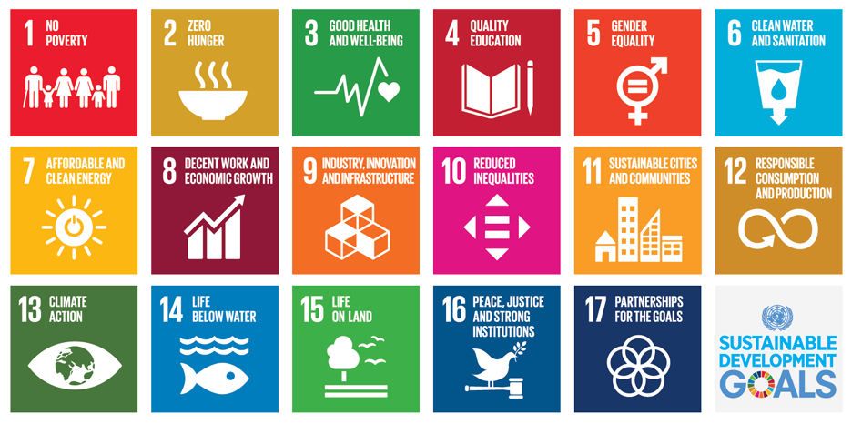

**All official project communications will be sent to the students from the following email address.**

**Official Mail id:** [scoagile.workgroup@srmist.edu.in](mailto:scoagile.workgroup@srmist.edu.in)

**Rubrics for Review 0**

|  |  |  |  |
| --- | --- | --- | --- |
| **Review /**  **Component** | **Rubrics** | **Performance** | **Status** |
| Review 0 | 1**. For Research oriented Projects**  [Abstract -Introduction- Literature survey- Research Gaps - Research Objectives - Project SDG - Plan of action]  OR  2. **For Product oriented projects**  [Abstract -Introduction- Product Vision Statement - Product Backlog - project SDG - Road Map]  3. Detailed Documentation [Review Report and PPT] | Excellent/Good  Poor | Accepted  Rejected |

**Note: 1. Students should submit Review 0 Report during the review.**